## VISVESVARAYA TECHNOLOGICAL UNIVERSITY

***“Jnana Sangama”, Belagavi -590018***



A

Internship Report

On

***“IPL Analysis Using Python”***

#### Submitted in the partial fulfillment of VIII semester

**BACHELOR OF ENGINEERING IN**

**COMPUTER SCIENCE AND ENGINEERING**

#### By NANDINI T K [1RL20CS050]

**Under the Guidance of Ms. Rekha M. S Assistant Professor**



**DEPARTMENT OF COMPUTER SCIENCE AND ENGINEERING**

## R.L. JALAPPA INSTITUTE OF TECHNOLOGY

#### DODDABALLAPUR - 561203

**2023-24**

## R.L. JALAPPA INSTITUTE OF TECHNOLOGY

**DODDABALLAPUR- 561203**



**DEPARTMENT OF COMPUTER SCIENCE AND ENGINEERING CERTIFICATE**

*This is to certify that the Internship seminar work entitled* ***“IPL Analysis Using Python”***

*is a bonafide work carried out by* ***Nandini TK (1RL20CS050)*** *in partial fulfillment for the requirement of VIII semester, Bachelor of Engineering in Computer Science and Engineering of* ***VISVESVARAYA TECHNOLOGICAL UNIVERSITY,*** *Belagavi during the year* ***2023-24.*** *It is certified that all corrections/suggestions indicated for the internal assessment have been incorporated in the report. This report has been approved as it satisfies the academic requirements in respect of seminar work prescribed for the said degree.*

|  |  |  |  |
| --- | --- | --- | --- |
|  | | |  |
| **Ms. Rekha M. S**  **Assistant Professor** |  | **Dr. P Vijayakarthik**  **HOD** | **Dr. P Vijayakarthik**  **Principal** |

#### Evaluator’s:

**1 .**

**2 .**

# ACKNOWLEDGEMENT

The satisfaction and euphoria that accompany the successful completion of any task would be incomplete without the mention of the people who made it possible and whose constant encouragement and guidance crowned my efforts with success.

We extend our deep sense of sincere gratitude to **Dr. P Vijayakarthik**, Principal, R L Jalappa Institute of Technology, Doddaballapur, for providing us an opportunity to continue our studies.

We express our heartfelt sincere gratitude to **Dr. P Vijayakarthik** , Head, Department of Computer Science and Engineering, R L Jalappa Institute of Technology, Doddaballapur, for his valuable suggestions and support.

We express our special in-depth, heartfelt, sincere gratitude  **Ms. Rekha M. S,**

Assistant Professor, Department of Computer Science and Engineering, R L Jalappa Institute of Technology, Doddaballapur for her constant support.

Finally, we would like to thank all the faculty and supporting staff members of Department of Computer Science and Engineering, R L Jalappa Institute of Technology, Doddaballapur, for their support.

NANDINI T K [1RL20CS050]

# ABSTRACT

Cranes Varsity is a pioneer Technical Training institute turned EdTech Platform offering Technology educational services for over 25 years. A division of Cranes Software International Ltd, Cranes Varsity was established with an ambitious vision of bridging the gap between the technology academia and the industry.The Indian Premier League (IPL) has emerged as one of the most prominent and lucrative cricket leagues globally, attracting vast audiences and generating significant data. This study leverages Python, a powerful programming language renowned for its data analysis capabilities, to conduct a comprehensive analysis of IPL data. The analysis focuses on multiple dimensions of the game, including player performance, team statistics, match outcomes, and historical trends.Python's extensive libraries, such as Pandas for data manipulation, Matplotlib and Seaborn for visualization, and Scikit-learn for machine learning, facilitate an in-depth examination of the IPL datasets. By employing these tools, we can uncover patterns, trends, and insights that are pivotal for teams, players, analysts, and fans. The study includes data cleaning, exploratory data analysis (EDA), and predictive modeling to forecast future performances and outcomes.The implications of this study are manifold, offering strategic insights for team management, enhancing fan engagement through data-driven storytelling, and contributing to the academic discourse on sports analytics. This analysis underscores the potential of Python as a versatile tool for sports data analysis, setting a precedent for future research in cricket and other sports.

# INTERNSHIP CERTIFICATE

# 

# TABLE OF CONTENTS

|  |  |  |
| --- | --- | --- |
| **1** | **Acknowledgement** | **i** |
| **2** | **Abstract** | **ii** |
| **3** | **Internship Certificate** | **iii** |
| **4** | **Table of contents** | **iv** |
| **5** | **List of Figures** | **v** |
| **Chapter No** | **Chapter Name** | **Page No** |
| **Chapter 1** | **Introduction** | **1-3** |
|  | 1.1 Company Profile | **1-3** |
|  | 1.2 About the company | **1-3** |
|  | 1.3 Products and Services | **1-3** |
|  | 1.4 Present Phase | **1-3** |
| **Chapter 2** | **About the Department** | **4** |
| **Chapter 3** | **Aim** | **5** |
| **Chapter 4** | **Requirement Specification** | **6** |
| **Chapter 5** | **Implementation** | **7-8** |
| **Chapter 6** | **Snapshot** | **9** |
|  | **Conclusion** | **10** |
|  | **Future Enhancement** | **11** |
|  | **References** | **12** |

**LIST OF FIGURES**

|  |  |  |
| --- | --- | --- |
| **Figure No** | **Name** | **Page No** |
| Figure 1.2 | Company Logo | 1 |
| Figure 1.3 | Services from Cranes Varsity | 3 |
| Figure 6.1 | Pi Chart of Field v/s Bat | 9 |
| Figure 6.2 | Bar Chart of Bat First v/s Bowl First | 9 |

# CHAPTER 1

* 1. **Company Profile**

**INTRODUCTION**

Cranes Varsity is a pioneer Technical Training institute turned EdTech Platform offering Technology educational services for over 25 years. A division of Cranes Software International Ltd, Cranes Varsity was established with an ambitious vision of bridging the gap between the technology academia and the industry.

### About the Company



Fig 1.2 Cranes Varsity Logo

Cranes Varsity is a renowned institution known for its expertise in technical training and professional development. With a strong focus on cutting-edge technologies like artificial intelligence, machine learning, cloud computing, and data science, Cranes Varsity equips individuals with the skills and knowledge necessary to thrive in the modern digital landscape.

Cranes Varsity also emphasizes hands-on learning through workshops, projects, and industry collaborations. This approach not only enhances technical skills but also fosters critical thinking, problem-solving abilities, and teamwork.

Moreover, Cranes Varsity offers a range of certification programs, diploma courses, and corporate training solutions, catering to diverse learning needs. Whether you're a student looking to kickstart your career or a professional aiming to upskill, Cranes Varsity provides a conducive environment for growth and success in the tech industry.

VIII Sem Dept of CSE, RLJIT 1 2023-2024

### Products and Services

Cranes Varsity is an Indian company that primarily operates in the field of technical training, consulting, and technology solutions. Here are some of the products and services they typically offer:

1. **Technical Training Programs:** Cranes Varsity provides technical training courses in various domains such as Embedded Systems, Internet of Things (IoT), VLSI (Very Large Scale Integration) Design, Robotics, Data Science, Artificial Intelligence (AI), Machine Learning (ML), and more. These programs are designed to cater to students, professionals, and corporates looking to enhance their skills and knowledge in these areas.
2. **Corporate Training:T**hey offer customized training solutions for companies and organizations, focusing on areas such as software development, embedded systems, IoT, automation, and emerging technologies. These training programs are tailored to meet the specific needs and objectives of each client.
3. **Consulting Services:** Cranes Varsity provides consulting services in areas like embedded systems design, IoT solutions, software development, product development, and technology strategy. They help businesses with technology adoption, process optimization, and product innovation.
4. **Technology Solutions:** The company offers end-to-end technology solutions, including product design, development, and testing services. They specialize in areas such as embedded software development, IoT solutions deployment, firmware development, and automation solutions.
5. **Seminars and Workshops :**Cranes Varsity conducts workshops, seminars, and webinars on various topics related to technology, innovation, and industry trends. These events provide a platform for knowledge sharing and networking among professionals and enthusiasts.
6. **Placement Assistance:** They offer placement assistance and career guidance to students completing their training programs, helping them connect with job opportunities in reputed companies.

#### Internships:

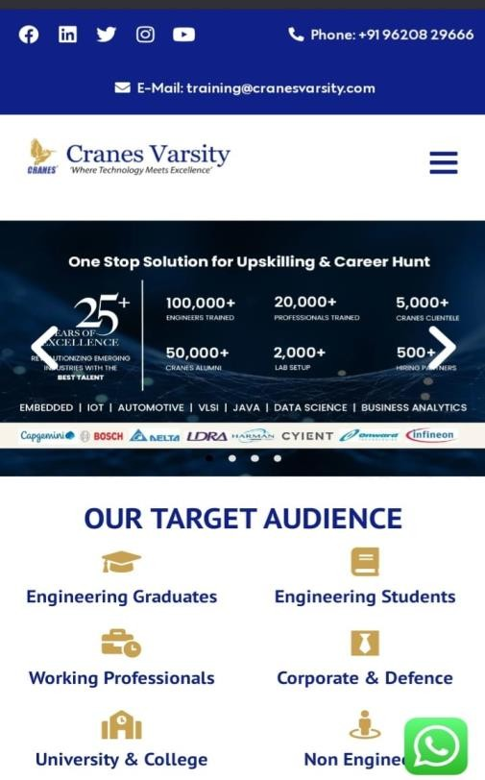

**Fig 1.3:** Services from Cranes Varsity

In this Data Science internship, you will delve into the foundational aspects of Python programming, mastering concepts like variables, loops, functions, and error handling. You'll then progress to NumPy, gaining expertise in numerical computing, array operations, and data manipulation. Pandas will be your go-to for data analysis, where you'll learn about Series, DataFrames, data cleaning, merging, and aggregation. Matplotlib will enhance your data visualization skills as you create a variety of plots to showcase insights effectively. Lastly, you'll dive into linear regression, a fundamental machine learning algorithm for predictive analysis. You'll understand regression assumptions, implement models using Python libraries, and evaluate their performance using metrics like R-squared and Mean Squared Error. Through hands-on projects, you'll apply these skills to real-world datasets, gaining practical experience in data science workflows from data preprocessing to model building and interpretation.

### Present Phase

* Head Quarters: Bengaluru, Karnataka, India
* CEO and Director : Asf Khader
* Co-founder : Mr.Khader and Mr. Mukarram Jan

# CHAPTER 2

## ABOUT THE DEPARTMENT

The Data Science Internship Program is a comprehensive learning journey that covers key topics such as Python, data analysis, statistical modeling, machine learning, data visualization, andpredictive modeling. Through a combination of theoretical instruction, practical exercises, and real-world projects, participants will gain valuable expertise in data-driven decision- making.

Under the guidance of experienced mentors, interns will work on cutting-edge data science projects, gaining practical skills in data preprocessing, feature engineering, model development, and evaluation. This hands-on experience will foster critical thinking, problem-solving abilities, and collaboration skills.

Cranes Varsity believes in a holistic approach to learning, and interns will have access to mentoring sessions, guest lectures, and interactive workshops. These opportunities will provide insights into industry trends, best practices, and real-world applications of data science.

The Data Science Internship Program is open to students pursuing degrees in computer science, statistics, or related fields. Prior knowledge of programming languages such as Python will be beneficial.

By participating in this internship, students will gain a competitive edge in the data science job market, equipped with both theoretical knowledge and practical experience. Cranes Varsity has a strong track record of producing industry-ready professionals, further solidifying the value of this program.

VIII Sem Dept of CSE, RLJIT 4 2023-2024

# CHAPTER 3

### AIM

The aim of an IPL analysis Python project can vary based on your interests and objectives. However, here's a broad aim you could consider:

"To develop a comprehensive IPL analysis Python project that utilizes historical match data, player statistics, and machine learning techniques to provide valuable insights, predictions, and visualizations for cricket enthusiasts, fantasy league players, and sports analysts."

This aim encompasses various aspects such as data collection, cleaning, analysis, visualization, and potentially predictive modeling, catering to a diverse audience interested in IPL cricket.

The aim for an IPL analysis Python project focusing on predictions could be:

"To build a predictive model using machine learning algorithms that leverages historical IPL match data, player performance statistics, team strategies, and external factors to accurately forecast match outcomes, player performances, key statistics, and trends for upcoming IPL seasons."

This aim emphasizes the development of a robust predictive model that can be utilized for making informed predictions related to IPL matches, players, and overall tournament dynamics.

# CHAPTER 4

## REQUIREMENT SPECIFICATION

### Software Requirements

**Development Environment**: Text Editor or IDE (e.g., Visual Studio Code, Jupiter Notebook).

A Jupiter Notebook is required for compiling the source code to make the executable file which can then be directly executed.

### Hardware Requirements

The hardware requirements are very minimal and the software can run on most of the machines.

* Processor - Intel 486/Pentium processor or above.
* Processor Speed - 500 MHz or above
* RAM - 64MB or above Storage Space - 2 MB or above, hard disk -10MB.
* Monitor resolution - A color monitor with a minimum resolution of 1000*700
* Supports both single &double buffering.

# CHAPTER 5

**5.1 Snippet of Code** import pandas as pd import numpy as np

## IMPLEMENTATION

import matplotlib.pyplot as plt import seaborn as sns

%matplotlib inline import warnings

warnings.filterwarnings('ignore') ata = pd.read_csv("matches.csv") data.head()

plt.figure(figsize = (18,10)) sns.countplot('season',data=data,palette="winter")

plt.title("Number of Matches played in each IPL season",fontsize=20) plt.xlabel("season",fontsize=15)

plt.ylabel('Matches',fontsize=15) plt.show()

plt.figure(figsize = (18,10)) sns.countplot(x='winner',data=data, palette='cool') plt.title("Numbers of matches won by team ",fontsize=20) plt.xticks(rotation=50)

plt.xlabel("Teams",fontsize=15) plt.ylabel("No of wins",fontsize=15) plt.show()

data['win_by']=np.where(data['win_by_runs']>0,'Bat first','Bowl first') Win=data.win_by.value_counts()

labels=np.array(Win.index) sizes = Win.values

colors = ['#FFBF00', '#FA8072']

plt.figure(figsize = (10,8))

plt.pie(sizes, labels=labels, colors=colors, autopct='%1.1f%%', shadow=True,startangle=90) plt.title('Match Result',fontsize=20) plt.axis('equal')

plt.show() Toss=data.toss_decision.value_counts() labels=np.array(Toss.index)

sizes = Toss.values

colors = ['#FFBF00', '#FA8072']

plt.figure(figsize = (10,8))

plt.pie(sizes, labels=labels, colors=colors, utopct='%1.1f%%', shadow=True,startangle=90) plt.title('Toss result',fontsize=20) plt.axis('equal')

plt.show()

wicket_data.groupby('bowler')['dismissal_kind'].agg(['count']).reset_index().sort

_values('count',ascending=False).reset_index(drop=True).iloc[:10,:]

Plt.show()

# CHAPTER 6

## SNAPSHOT

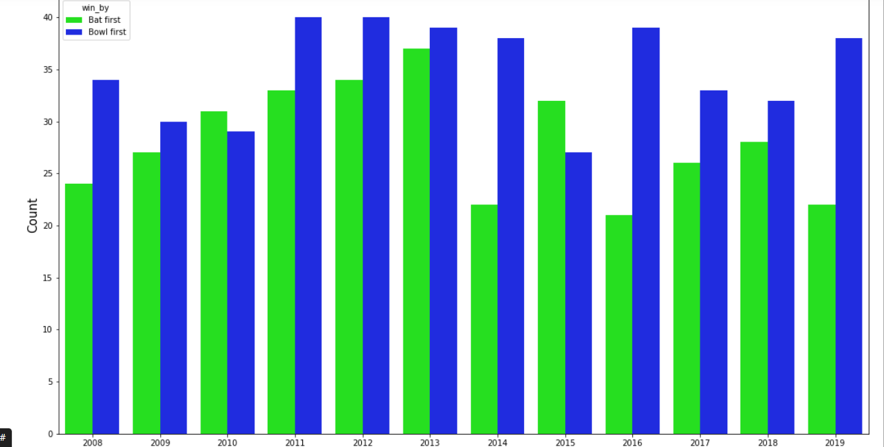**Fig 6.1**: Pi Chart of Field v/s Bat

**Fig 6.2**: Bar Chart of Bat First v/s Bowl First

## CONCLUSION

In conclusion, this IPL analysis project has provided valuable insights into various aspects of the Indian Premier League. We started by gathering data from reliable sources such as Kaggle and using Python libraries like Pandas, Matplotlib, and Seaborn for data manipulation and visualization. Exploratory data analysis helped us understand the distribution of runs, wickets, and other important statistics across teams and seasons.

We delved deeper into player performance, identifying top performers based on batting and bowling averages, strike rates, and economy rates. This analysis can be beneficial for team management, helping them make informed decisions during auctions or team selections.

Furthermore, we used machine learning techniques such as linear regression to predict match outcomes based on historical data. This predictive model can be refined and extended in the future to incorporate more features and improve accuracy.

Overall, this project demonstrates the power of Python and data analysis in extracting meaningful insights from sports data, which can be applied in various domains within the cricketing industry.

## Future Enhancement

Here are some potential future enhancements you could consider for your IPL analysis Python project:

1. Live Match Analysis: Integrate live data fetching APIs to provide real-time analysis during IPL matches. This could include live player performance metrics, team strategies, and predictions.
2. Social Media Sentiment Analysis: Incorporate sentiment analysis of social media data related to IPL teams, players, and matches. This can provide insights into fan sentiment and reactions.
3. Machine Learning Predictions: Develop and integrate machine learning models for predicting match outcomes, player performances, and key statistics based on historical IPL data.
4. Interactive Visualizations: Enhance the project with interactive data visualizations using libraries like Plotly or Bokeh. This can make the analysis more engaging and informative.
5. Fantasy League Integration: Create a feature that integrates with popular fantasy cricket platforms, allowing users to get insights and suggestions for their fantasy teams based on your analysis.
6. Player Performance Comparison: Implement a feature to compare the performance of different players across seasons, teams, or match formats using statistical analysis.
7. Injury Analysis and Impact: Include data on player injuries and their impact on team performance. This could involve tracking player recovery times and performance before and after injuries.
8. Match Simulation: Develop a match simulation module where users can simulate IPL matches based on historical data and different scenarios.
9. Player Auction Analysis: Analyze IPL player auctions using data analytics techniques to assess player values, team strategies, and auction trends.
10. Mobile App Integration: Convert your project into a mobile app for easy access and engagement for users interested in IPL analysis on the go.

# REFERENCES

1. Cranes Varsity website, Available: https://cranesvarsty.in/
2. Next.js : Available: https://nextjs.org/
3. YouTube, Available: [www.youtube.com](http://www.youtube.com/)
4. W3Schools, Available: [www.w3schools.com](http://www.w3schools.com/)
5. Tutorials Point Website, Available: [www.tutorialspoint.com/php/](http://www.tutorialspoint.com/php/)
6. Wikipedia Website, Available: [www.wiki.com](http://www.wiki.com/)